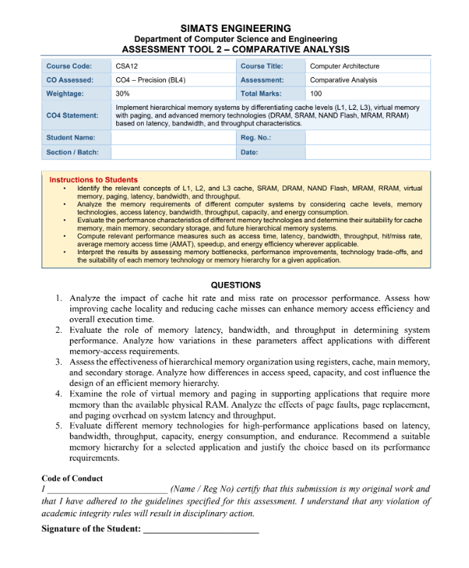
K SANDHIYA
(192521378)
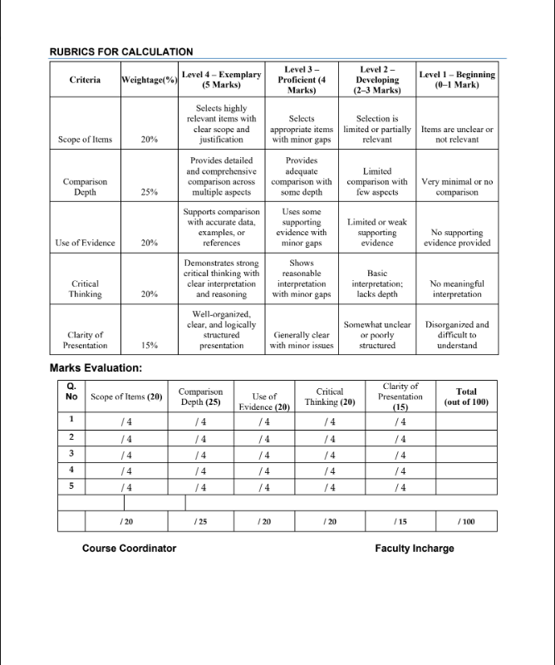

Analysis of Memory Hierarchy and Memory Performance
1. Impact of Cache Hit Rate and Miss Rate on Processor Performance
Cache memory is a small, high-speed memory located close to the processor. It stores frequently or recently accessed data and instructions so that the CPU can access them faster than from main memory.
The cache hit rate is the percentage of memory requests that are successfully served by the cache. A higher cache hit rate improves processor performance because the CPU spends less time waiting for data from slower memory. The cache miss rate is the percentage of requests that cannot be found in the cache. A cache miss forces the processor to access a lower level of the memory hierarchy, increasing memory access time.
The average memory access time can be approximately expressed as:
AMAT = Hit Time + (Miss Rate × Miss Penalty)
Therefore, reducing the miss rate directly reduces the average memory access time.
Cache locality is important for achieving a high hit rate. There are two major types:
- Temporal locality: Recently accessed data is likely to be accessed again.
- Spatial locality: Data located near recently accessed data is likely to be accessed soon.
Programs that use arrays sequentially, for example, generally have good spatial locality. Organizing data structures efficiently, reusing frequently accessed data, and optimizing loops can improve locality.
A higher cache hit rate reduces processor stalls, improves memory access efficiency, and decreases overall execution time. Conversely, frequent cache misses increase memory traffic and can cause the CPU to remain idle while waiting for data.

2. Role of Memory Latency, Bandwidth, and Throughput
Three important factors determine memory-system performance: latency, bandwidth, and throughput.
Memory Latency
Latency is the time required to begin obtaining data after a memory request is made. Low latency is particularly important for applications involving many small or random memory accesses.
For example, databases, operating systems, and pointer-based data structures can perform poorly when memory latency is high because each access may depend on the result of a previous access.
Memory Bandwidth
Bandwidth represents the amount of data that can be transferred between memory and the processor per unit of time, usually measured in GB/s.
High bandwidth is important for applications that process large amounts of data, such as:
- Scientific simulations
- Image and video processing
- Artificial intelligence and machine learning
- Graphics processing
- Large-scale data analytics
Increasing bandwidth allows more data to be transferred simultaneously and can significantly improve performance when an application is bandwidth-limited.
Memory Throughput
Throughput is the amount of useful work or data that the memory system can process over a given period. High throughput depends on factors such as bandwidth, memory concurrency, access patterns, and the ability of the processor to issue multiple memory requests.
Applications with random and latency-sensitive accesses benefit mainly from low latency, whereas applications performing large sequential transfers benefit more from high bandwidth and throughput.
Thus, no single memory characteristic determines performance for every application. The appropriate memory technology depends on the application's access pattern.
3. Effectiveness of Hierarchical Memory Organization
A computer uses a hierarchy of memory because it is impossible to provide very large amounts of extremely fast memory at a reasonable cost.
A typical hierarchy is:
Registers → Cache → Main Memory (RAM) → Secondary Storage
Registers
Registers are located inside the CPU and provide the fastest data access. However, their capacity is extremely small and they are expensive per bit.
Cache
Cache memory, such as L1, L2, and L3 cache, is faster than RAM but has much smaller capacity. It stores frequently used instructions and data.
Main Memory
RAM provides considerably more capacity than cache but has higher access latency. It stores the programs and data currently being used by the operating system and applications.
Secondary Storage
SSDs and hard drives provide very large storage capacity at a lower cost per bit. However, they are much slower than RAM.
The hierarchy works because programs tend to exhibit locality of reference. Frequently used information remains in faster levels while less frequently used information is stored in slower, larger levels.
Memory Level | Speed | Capacity | Cost per Bit
Registers | Extremely high | Very small | Very high
Cache | Very high | Small | High
RAM | High | Medium/Large | Moderate
SSD/HDD | Low compared with RAM | Very large | Low
An efficient memory hierarchy therefore balances speed, capacity, and cost. Fast memories are used for the most frequently accessed information, while slower technologies provide large-scale storage.

4. Virtual Memory and Paging
Virtual memory allows a system to run applications whose total memory requirements exceed the available physical RAM. It gives each process the illusion of having a large, continuous memory space.
Virtual memory commonly uses paging, where virtual memory is divided into fixed-size pages and physical memory is divided into corresponding frames. When a required page is not currently present in RAM, a page fault occurs.
The operating system then:
- Detects the page fault.
- Finds the required page on secondary storage.
- Selects a free memory frame or chooses an existing page for replacement.
- Loads the required page into RAM.
- Updates the page table.
- Restarts the interrupted instruction.
Page faults are much slower than normal RAM accesses because they involve secondary storage. A high page-fault rate can therefore cause a major reduction in system performance.
Page Replacement
When RAM is full, the operating system must choose a page to remove. Algorithms such as Least Recently Used (LRU) and related replacement strategies attempt to remove pages that are unlikely to be needed soon.
Poor page replacement decisions can increase page faults and reduce performance.
Paging Overhead
Paging requires CPU time and operating-system activity for address translation, page-table management, and page transfers. Excessive paging can result in thrashing, where the system spends most of its time moving pages between RAM and storage instead of executing useful application instructions.
Therefore, virtual memory provides flexibility and allows large applications to execute, but excessive page faults increase latency and reduce throughput.

5. Evaluation of Memory Technologies and Recommended Memory Hierarchy
Different memory technologies provide different combinations of latency, bandwidth, capacity, energy consumption, and endurance.
SRAM
SRAM is very fast and is commonly used for CPU caches. It has low latency but relatively high cost and low density. It is therefore unsuitable for providing very large amounts of main memory.
DRAM
DRAM is commonly used as system RAM. It offers much greater capacity than SRAM at a lower cost per bit, although it has higher latency. Modern DRAM provides substantial bandwidth and is suitable for general-purpose computing and data-intensive applications.
NAND Flash
NAND flash is widely used in SSDs. It provides high storage density, low power consumption compared with many mechanical storage technologies, and much faster access than traditional hard disks. However, it has higher latency than RAM and a finite write endurance.
HDD
Hard disk drives provide large capacity at low cost but have high mechanical latency and relatively low random-access performance. They are therefore less suitable for latency-sensitive high-performance applications.
Comparison
Technology | Latency | Bandwidth | Capacity | Energy | Endurance
SRAM | Very low | Very high | Very small | Relatively high | Very high
DRAM | Low | High | Large | Moderate | Very high
NAND Flash | Higher | High sequential performance | Very large | Low/moderate | Limited write endurance
HDD | Very high | Low/moderate | Very large | Higher during operation | Mechanical limitations
Recommended Hierarchy: AI/Deep-Learning Application
For a high-performance AI or deep-learning system, the memory hierarchy should prioritize high bandwidth while maintaining low latency for frequently accessed data.
A suitable hierarchy is:
CPU/GPU Registers → L1/L2 Cache → Large L3 Cache → High-Bandwidth DRAM/HBM → NVMe SSD → Long-term Storage
Registers and caches provide extremely fast access to frequently reused data. High-bandwidth memory such as HBM can provide very high data-transfer rates for workloads that repeatedly process large datasets. SSD storage can hold datasets that cannot fit in RAM, while slower storage can be used for long-term data retention.
This hierarchy is effective because it places the most frequently and urgently needed data in the fastest memory while using high-capacity technologies for less frequently accessed data.
Conclusion
Memory-system performance has a direct impact on overall processor performance. A high cache hit rate reduces memory stalls, while good cache locality minimizes expensive cache misses. Low memory latency benefits applications with frequent random accesses, whereas high bandwidth and throughput are especially important for data-intensive applications.
The hierarchical memory system provides an effective balance between speed, capacity, and cost by combining registers, caches, RAM, and secondary storage. Virtual memory further extends the usable memory capacity, although excessive page faults and paging can significantly reduce performance.
For high-performance applications, the best solution is not simply to use the fastest memory everywhere. Instead, an efficient system combines different memory technologies according to their latency, bandwidth, capacity, energy consumption, and endurance characteristics. This approach provides high performance while keeping the overall system practical and cost-effective.

